AIM - A) Implement the Breadth First Search algorithm to solve a given problem.
B) Implement the Iterative Depth First Search algorithm to solve the same problem.
C) Compare the performance and efficiency of both algorithms.
A.
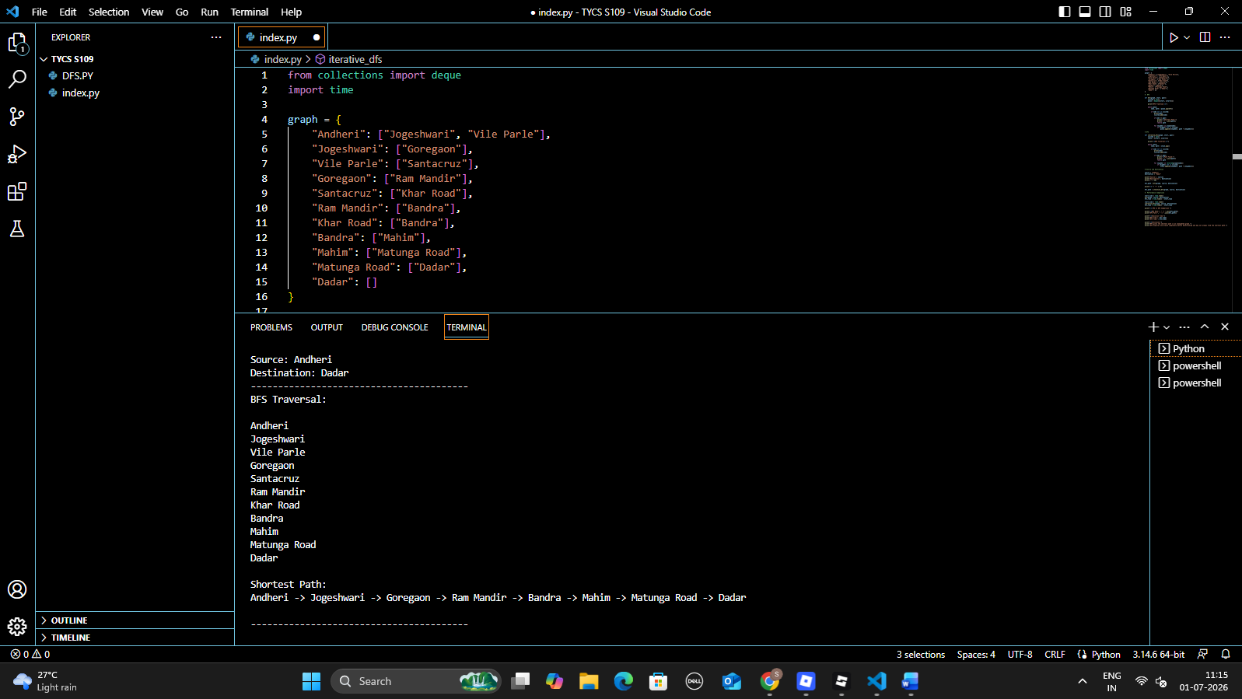
B
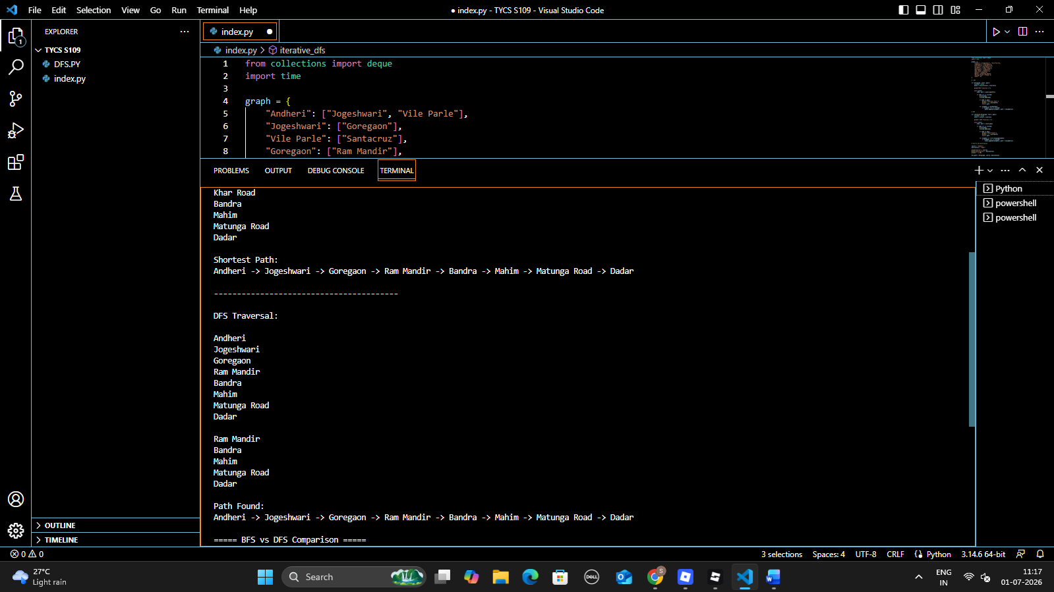
C.
